SQL Validation Report: Pizza Sales

1. Core KPIs (Single Value Metrics)
Purpose: To validate card visuals and high-level summary metrics.
Metric Name | Result Value | Source Evidence
Total Revenue | 817,860.05
Average Order Value | 38.307
Total Pizzas Sold | 49,574
Total Orders | 21,350
Avg Pizzas Per Order | 2
Export to Sheets

SQL Statements Used:
Total Revenue:
SQL
SELECT SUM(total_price) AS Total_Revenue
FROM pizza_sales
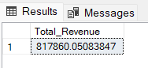
Average Order Value:
SQL
SELECT SUM(total_price) / COUNT(DISTINCT(order_id)) AS Average_Order_Value
FROM pizza_sales
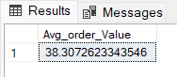
Total Pizzas Sold (Quantity):
SQL
SELECT SUM(quantity) AS Total_Orders
FROM pizza_sales
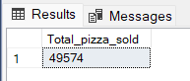
Total Orders (Count):
SQL
SELECT COUNT(DISTINCT(order_id)) AS Total_Orders
FROM pizza_sales
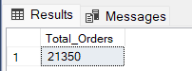
Avg Pizzas Per Order:
SQL
SELECT CAST(CAST(SUM(quantity) AS DECIMAL(10,2)) /
CAST(COUNT(DISTINCT order_id) AS DECIMAL(10,2)) AS DECIMAL(10,2))
AS Avg_Pizzas_per_order
FROM pizza_sales
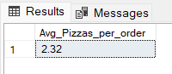

2. Temporal Trends (Charts & Graphs)
Purpose: To validate line charts and bar charts tracking performance over time.

A. Daily Trend (Orders by Day of Week)
Query:
SQL
SELECT DATENAME(DW,order_date) AS order_date, COUNT(DISTINCT(order_id))
FROM pizza_sales
GROUP BY DATENAME(DW,order_date)
Results:
- Friday: 3,538
- Thursday: 3,239
- Saturday: 3,158
- Wednesday: 3,024
- Tuesday: 2,973
- Monday: 2,794
- Sunday: 2,624
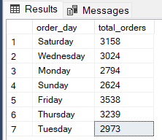

B. Monthly Trend (Orders by Month)
Query:
SQL
SELECT DATENAME(MONTH, order_date), COUNT(DISTINCT(order_id)) AS Total_Orders
FROM pizza_sales
GROUP BY DATENAME(MONTH, order_date)
ORDER BY Total_Orders DESC
Results (Top 3):
- July: 1,935
- May: 1,853
- January: 1,845 (Lowest month: October with 1,646)
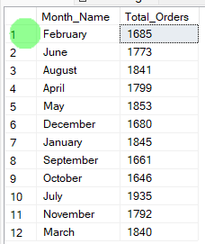

3. Product & Size Distribution (Donut/Pie Charts)
Purpose: To validate breakdown visuals.

A. Sales by Pizza Category
Query:
SQL
SELECT pizza_category, CAST(SUM(total_price) AS DECIMAL(10,2)) as total_revenue,
CAST(SUM(total_price) * 100 / (SELECT SUM(total_price) from pizza_sales) AS DECIMAL(10,2)) AS PCT
FROM pizza_sales
GROUP BY pizza_category
Results:
- Classic: 26.91%
- Supreme: 25.46%
- Chicken: 23.96%
- Veggie: 23.68%
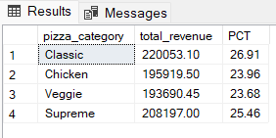

B. Sales by Pizza Size
Query:
SQL
SELECT pizza_size, CAST(SUM(total_price) AS DECIMAL(10,2)) as total_revenue,
CAST(SUM(total_price) * 100 / (SELECT SUM(total_price) from pizza_sales) AS DECIMAL(10,2)) AS PCT
FROM pizza_sales
GROUP BY pizza_size
ORDER BY pizza_size
Results:
- L: 46%
- M: 30%
- S: 22%
- XL: 2%
- XXL: 0%
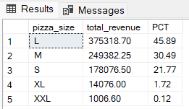

4. Rankings: Top 5 vs Bottom 5
Purpose: To validate "Top N" lists and ranking tables.

A. Rankings by Revenue (Total_Price)
Query Structure: ORDER BY Total_Sales DESC (Top) and ASC (Bottom).
G. Top 5 Pizzas by Revenue
SELECT Top 5 pizza_name, SUM(total_price) AS Total_Revenue
FROM pizza_sales
GROUP BY pizza_name
ORDER BY Total_Revenue DESC
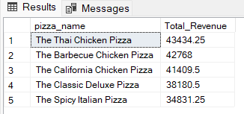
H. Bottom 5 Pizzas by Revenue
SELECT Top 5 pizza_name, SUM(total_price) AS Total_Revenue
FROM pizza_sales
GROUP BY pizza_name
ORDER BY Total_Revenue ASC
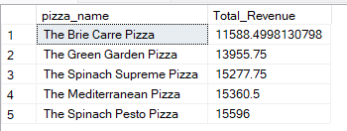

B. Rankings by Quantity Sold
Query Structure: ORDER BY Total_quantity DESC (Top) and ASC (Bottom).
I. Top 5 Pizzas by Quantity
SELECT Top 5 pizza_name, SUM(quantity) AS Total_Pizza_Sold
FROM pizza_sales
GROUP BY pizza_name
ORDER BY Total_Pizza_Sold DESC
Output
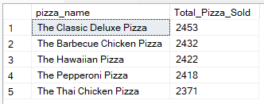
J. Bottom 5 Pizzas by Quantity
SELECT TOP 5 pizza_name, SUM(quantity) AS Total_Pizza_Sold
FROM pizza_sales
GROUP BY pizza_name
ORDER BY Total_Pizza_Sold ASC
Output
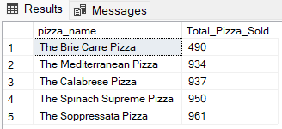

C. Rankings by Total Orders
Query Structure: ORDER BY Total_orders DESC (Top) and ASC (Bottom).
K. Top 5 Pizzas by Total Orders
SELECT Top 5 pizza_name, COUNT(DISTINCT order_id) AS Total_Orders
FROM pizza_sales
GROUP BY pizza_name
ORDER BY Total_Orders DESC
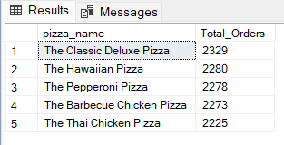
L. Borrom 5 Pizzas by Total Orders
SELECT Top 5 pizza_name, COUNT(DISTINCT order_id) AS Total_Orders
FROM pizza_sales
GROUP BY pizza_name
ORDER BY Total_Orders ASC
